Calendar of Events
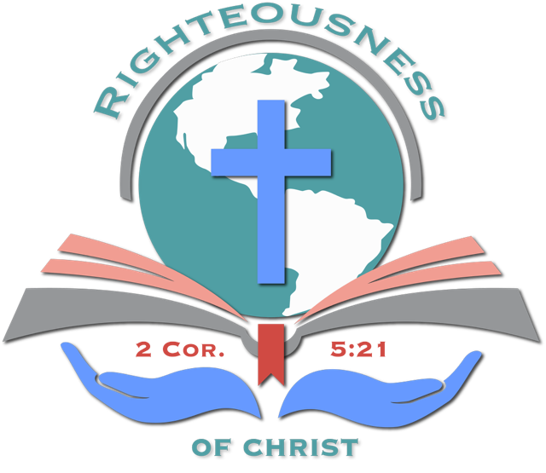

Righteousness of Christ Fellowship, Inc. (2026)
Month | Date(s) | Event Name | Description / Notes | Location
January | 5th | New Year Consecration Service | A time of prayer, fasting, and dedication | Sanctuary
February | 22nd | Black History Program | Celebrating our history | Sanctuary
March |  | Prayer Board | Women Gathering for Prayer | Sanctuary
April |  | Resurrection Sunday Celebration | Easter service and outreach | Sanctuary
May | 23rd | ROC’s Anniversary | Third Ministry Anniversary | Double Tree Hotel Largo, MD
July |  | Prayer Breakfast | Mid-Year Prayer Focus (Nation, Churches, Family, Health, Salvation)
July |  | Community Outreach Day | Evangelism, food distribution, and family fun
August |  | Leadership Seminar | Training and vision casting for ministry leaders | TBD
October | 17th | Women Tea | Women’s Tea  Theme: Women Embracing Unlimited Possibili-TEAs (Suggestion) | On the BOCCM’s Grounds
October | 25th | Harvest Gathering | Family-friendly Day fall celebration | Sanctuary
November | 15th | Thanksgiving Worship & Service Day | Gratitude for service and Friends-Giving | Sanctuary
December | 20th | Christmas & Toy Drive | Musical celebration and gift distribution | Sanctuary

